YOUR CONTACT DETAILS

Organisation:
Organiser: | Tel:
Address: | E-mail:
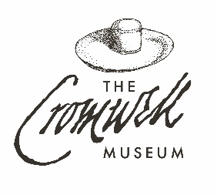
Guided Tour Booking Form
2026 Fees
1-2 Tours: £8 adults
£7 seniors, students, under-16s
3+ tours: £12 adults
£10 seniors, students, under-16s
Minimum Fee £70 (£90 out of hours)

TOUR DETAILS
Date: | Arrival time: |  | Departure time:
Group leader: |  | Contact mobile number:
Number in group: |  | Type of group:

Please specify any additional requirements (e.g. seating required, wheelchair access, foreign language interpretation):
Tour(s) required (tick which):
☐ Cromwell Museum ☐ Huntingdon Town Hall ☐ Cromwell’s Huntingdon

Signed (Organiser): | Date:

Do you want to be added to our mailing list to stay informed with what’s on at the Museum? YES / NO

Tour Details
We offer three tour elements, each lasting about 40 minutes: a tour of the Cromwell Museum and its collections, of Huntingdon Town Hall including the 18th century Assembly Room and Law Courts, and a walking tour of the key historic buildings and sites associated with Cromwell around Huntingdon. Our tours are fully accessible for wheelchairs, and all three have a maximum of 18 people per tour. For larger groups, we can split your group and rotate them between different tour elements.
Cancellation and Delays
A cancellation charge of 50% of the cost of the guided tour is charged if cancelled less than 14 days before the tour; the full cost of the tour is payable if cancelled less than 7 days before the tour. Please phone the Museum on (01480) 708008 if you are delayed; guides will usually wait up to 30 minutes. If this period is exceeded without contact from the organiser to inform us as to the delay, the tour may be cancelled, a cancellation fee charged or the tour shortened at the guide’s discretion.
Getting to us
Coaches may drop off/pick up the group in Huntingdon Bus Station, less than 2 minutes’ walk from the Museum and Town Hall. The nearest car park is just behind the Museum on St Germain Street (pay and display). The Museum is about 8 minutes’ walk from Huntingdon Railway Station, which is on the East Coast line with regular trains from King’s Cross and Peterborough.
Other Facilities
Toilets (including accessible toilets) are available in the Town Hall. By prior arrangement we can hold baggage for groups at the Town Hall during your tour. There are many cafes, restaurants, pubs and hotels in the immediate area of the Museum for refreshments – please ask us for more details.

