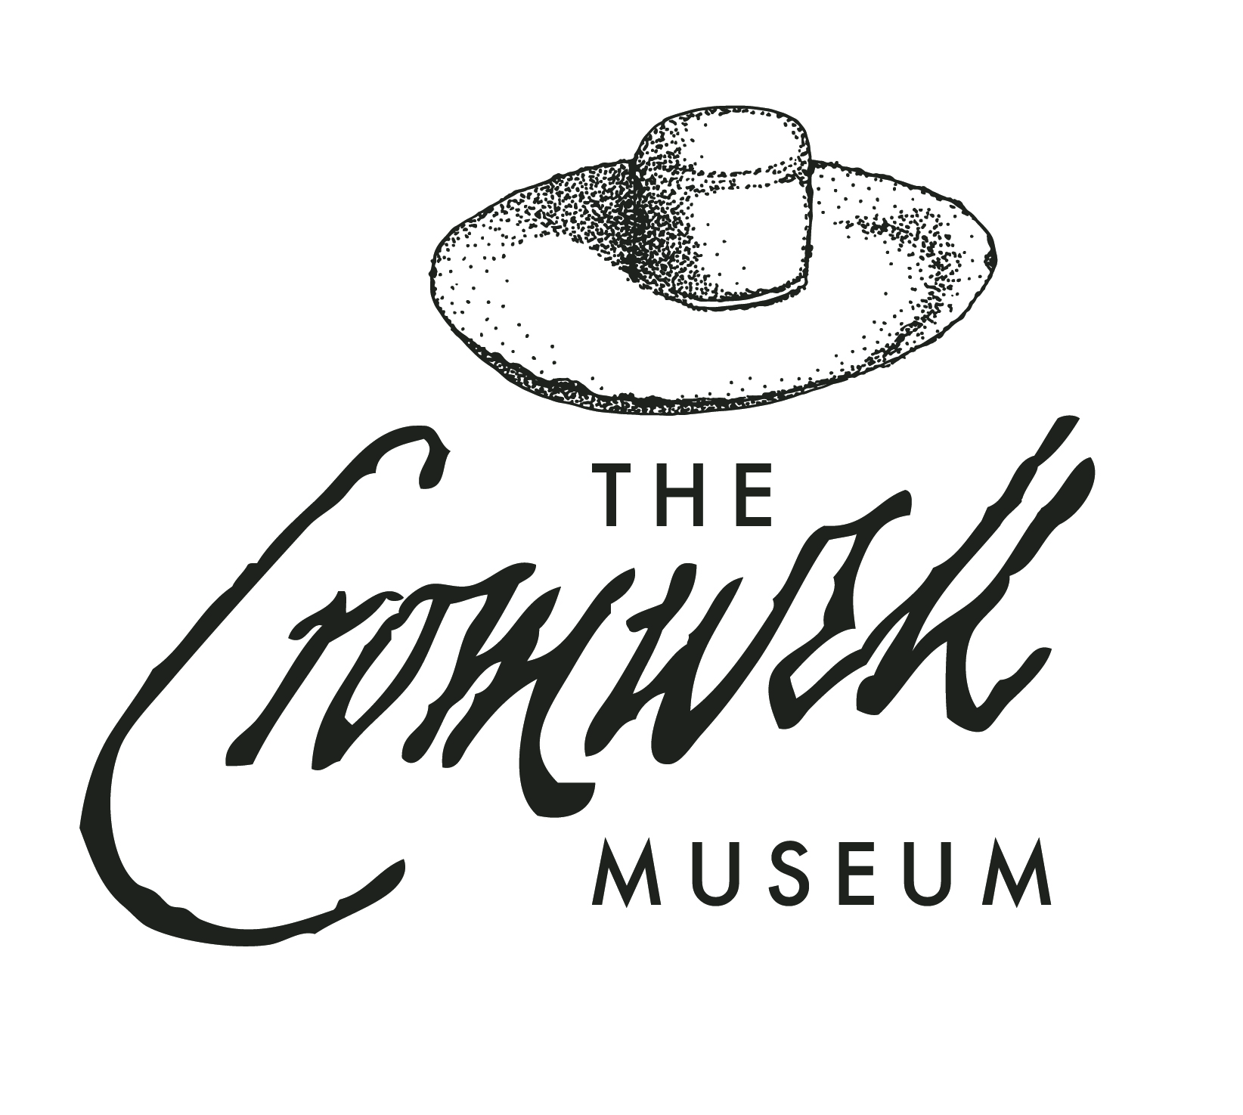
Cromwell Museum Risk Assessment Form for School and Group Visits

The Cromwell Museum aims to provide a safe and enjoyable learning experience. The information below is designed to aid visiting schools and community groups in the preparation of health and safety and risk assessment documentation prior to their visit. The Cromwell Museum makes no guarantee that this assessment form is suitable for every eventual need and so recommends that all teachers and group leaders take their own professional advice when drawing up their risk assessment and using this guidance. We can welcome teachers and group leaders to the museum for a planning visit before the group visit to assess potential hazards for yourself, both onsite and on your journey to us. This risk assessment has been adapted to include Covid-19-associated risks and precautions.

Please contact the Learning and Communities Officer at learning@cromwellmuseum.com or at 01480 702216 if you have any questions about the information provided in this risk assessment, or if you need further information.

Activity to be assessed: Cromwell Museum School/Group Visit Date of assessment: 22 August 2024

ACTIVITY | HAZARDS/RISKS | RISK LEVEL | PRECAUTIONS | ADDITIONAL MEASURES
Covid-19 Risks and Measures
Being in an enclosed space – Museum/Town Hall | Chance of Covid-19 airborne transmission | Medium | Upon request from the visiting group, Museum staff and volunteers will wear masks and/or clear face shields, sanitise hands, and stay socially distanced (as much as possible) from the school group throughout the session.  Hand sanitiser is available for school children and teachers to use upon entering the Town Hall and Museum. Students over the age of 11 and all accompanying adults are encouraged to wear masks while inside according to their school policies, unless exempt. | Any additional pre-cautions as requested by the school will be followed to the best of the Museum’s abilities.
Touching shared surfaces – Museum/Town Hall | Chance of Covid-19 surface transmission | Low | Surfaces likely to be touched by the school group will be sanitised before and after the visit. | As above.
Handling museum artefacts and activity props | Chance of Covid-19 transmission | Low | The object will be sanitised before and after a session. Hand sanitiser will be available for students to use if desired. | As above.
General School Visits Risks and Measures
Having break and lunch at the Town Hall | People moving around while eating  Allergies and intolerances | Low | On their break, children will sit in the provided room on benches or chairs.  Children to eat and drink only what they bring with them. The visiting school is responsible for the snacks, lunch and drinks the children bring. | Teachers and other school staff are responsible for the behaviour and safety of the children in their care at all times.
Handling museum artefacts and activity props | Dropping an object and causing injury.  Injuring self by handling object.  Risk of black powder being present on replica weapons and sparking. | Medium | Museum staff and volunteers will explain correct handling procedures.  Children handling the objects will do so under supervision of adults who accompany them from school as well as museum staff and volunteers.  Handling objects have been assessed for safety, and are non-hazardous in nature. | As above  Teachers are asked that they ensure the children under their care listen to instructions from staff carefully.
Looking carefully at items in collection. | Chance of breakage, knocking over of the object, and injury to children. | Low | Most objects are cased in museum standard display cases with safety glass. Uncased objects have been assessed and are non-hazardous. Heavy or unstable objects are secured to prevent danger from falling on and injuring visitors.  Children will be encouraged to look at the details of such objects from a safe distance, but warned not to touch for any reason. | As above
Moving from Museum to Town Hall at beginning and end of workshop. | Occasional traffic in Market Square | Medium | Market Square is a pedestrianised area. Children will be organised in pairs to walk across the square in a group, with teachers/group leaders at the front and back of the line. | As above
Walking on sidewalks alongside roads during guided or self-guided tour. | Traffic on street. | Medium | The tour will stick to sidewalks and other pedestrianised areas. Road crossings will be done only when safe and legal. Children will be organised in pairs to walk, with teachers/group leaders at the front and back of the line. | Teachers and other school staff are responsible for the behaviour and safety of the children in their care at all times.
Moving around the museum | Slips, trips and falls | Low | Public areas are kept clear of trip/slip hazards.  Visitors to the museum are asked not to run while on the premises. | As above  Teachers/group leaders are advised to give a safety talk to their pupils before visiting the museum
Toilets |  | Low | There are toilets available for use in the Town Hall, including accessible toilets. | As above  Teachers/group leaders are asked to supervise toilet visits.
Additional needs/requirements |  | Low | The museum and Town Hall are accessible to wheelchair users, however the museum must be informed of specific needs, and numbers of wheelchair users in advance, as these will be limited due to emergency evacuation procedures. | Teachers/group leaders are asked to alert the museum upon booking if there are any special needs/requirements of individual children, and must bring the correct ration of adults to children.
First aid |  | Low | There are first aid kits available at the museum and in the Town Hall. Museum staff and volunteers will call for medical assistance if required. | Teachers/group leaders must alert a member of staff if medical assistance is required.  Teachers/group leaders are responsible for providing and administering first aid to their own group while at the museum or Town Hall.
Evacuation due to fire or other disaster. | Severe personal injury | Low | Museum staff and volunteers to gather students and evacuate according to site guidelines to safe gathering spot.
Personal belongings | Theft | Low | Personal belongings, including bags and coats, will be left in a secure room in the Town Hall building. The Town Hall is currently closed to the general public. | Nothing expensive or irreplaceable should be left in the secure room.

